INTERNATIONAL CENTRE FOR PROFESSIONAL DEVELOPMENT (ICPD), FUNAAB.

INTENSIVE WEBSITE DEVELOPMENT TRAINING

Assignment I

1. Explain the following layers of the website and state the language(s) used while working in each layer:

* Content layer
* Presentation layer
* Behavior layer

1. What is the main function of CSS?
2. List the three methods of using CSS; which of these methods is the best?
3. Using HTML and CSS only, produce the following wireframes:

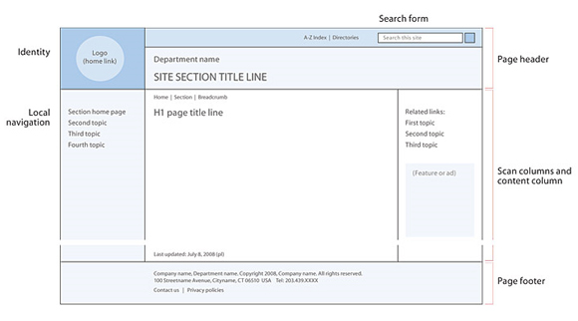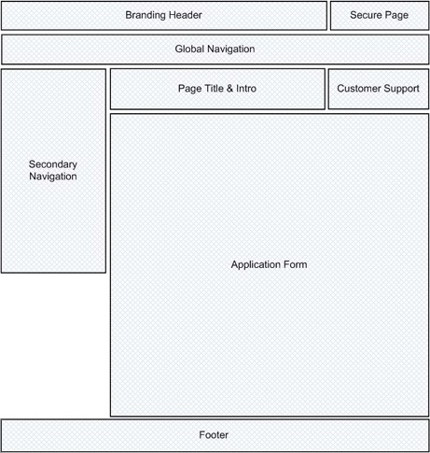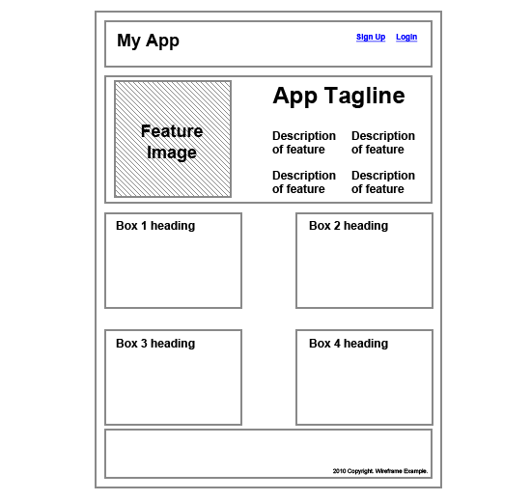

Note: answer questions 1 and 2 on an A4 paper, question 3 is practical, write the codes.

Hint to question 3: create the components with ***div***, and then use ***CSS*** to manipulate the ***height*** and ***width*** properties.

Good luck!

-Steve